METRO RETAIL SALES ANALYSIS
INTRODUCTION
Metro Retail Store is a multi-category retail business serving individual customers across a broad range of everyday and lifestyle products. Its catalogue spans electronics, clothing, footwear, accessories, home items, sports equipment, beauty products, and groceries, and it sells through both card and cash-on-delivery payment options.
Like many modern retailers, the business operates in an environment of changing customer preferences, seasonal demand swings, and strong price competition. Discounts are used regularly to attract buyers, but it is not always clear how far they influence spending, customer satisfaction, or repeat purchases. Management therefore wants a clearer, evidence-based picture of how the business is performing and who its customers are.
This analysis examines the store’s customer transaction data, covering customer demographics, product categories, purchase amounts, seasons, payment methods, item ratings, discounts, and purchase history. The aim is to uncover patterns in sales performance, customer behaviour, and product satisfaction, and to turn them into practical recommendations on pricing, discounting, inventory planning, and customer retention.

Objectives
- Identify the highest and lowest revenue-generating categories and items.
- Analyse how age and gender influence purchasing behaviour and spending.
- Examine seasonal trends to support stock and promotion planning.
- Assess the relationship between discounts, item ratings, and purchase amounts.
- Compare payment methods and their share of total sales.

DATA CLEANING
The dataset was obtained in a pre-cleaned state, so no major cleaning was required. The records were free of duplicate entries, and the columns were consistently formatted and labelled.
The only change made was to the Amount column. The transaction values were originally stored as plain numbers with no currency symbol, so they were formatted as US Dollars ($) to give a clear, standard presentation of the financial figures.
This was a formatting change only. No values were converted or altered, so relative differences between transactions, categories, and customers were unaffected. All monetary figures in this report are expressed in US Dollars.
No other changes were made to the data. It was then loaded into the analysis environment, ready for exploration and visualisation.

ANALYSIS
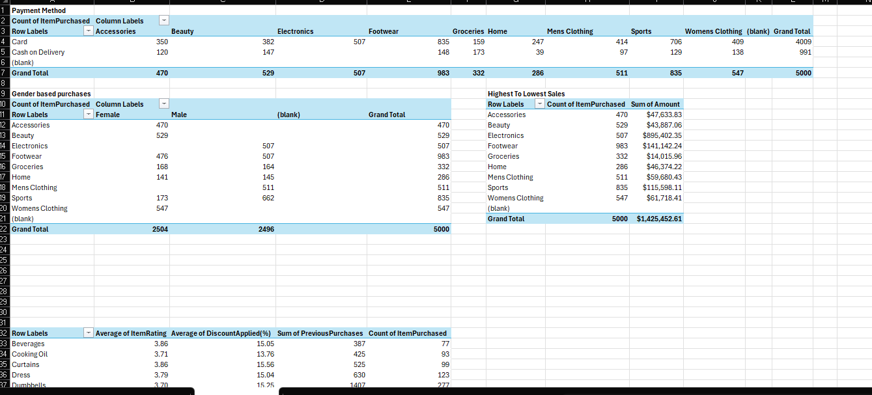
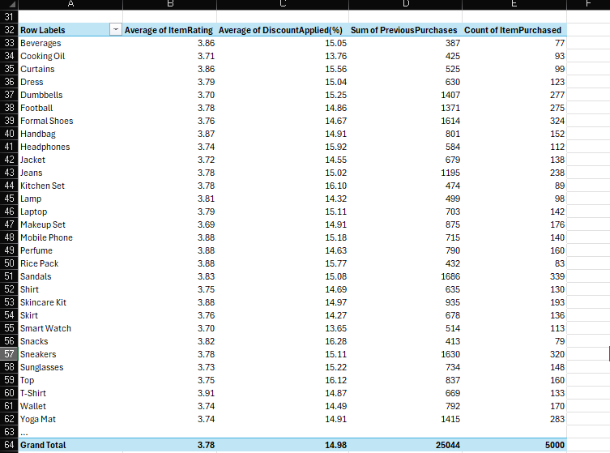

DATA ANALYSIS
After the data was cleaned, the analysis was carried out entirely with Excel PivotTables, and PivotCharts were built from them to make the results easier to visualise. The pivot tables summarised the 5,000 transactions by payment method, gender, product category, and item-level ratings and discounts.
Payment Method by Category
Card payments account for 4,009 of the 5,000 transactions, while Cash on Delivery accounts for 991. Card is the dominant method in every category.
Gender-Based Purchases
The dataset is almost evenly split, with 2,504 female and 2,496 male customers. Accessories, Beauty and Women's Clothing appear only under female customers, while Electronics and Men's Clothing appear only under male customers. Footwear, Groceries, Home and Sports are bought by both.
Highest to Lowest Sales by Category
Total sales come to $1,425,452.61. Electronics leads at $895,402.35, over 60% of all revenue, followed by Footwear ($141,142.24) and Sports ($115,598.11). Groceries generated the least at $14,015.96, despite recording 332 purchases.
Ratings, Discounts and Previous Purchases by Item
Ratings and discounts are consistent across items. The overall average rating is 3.78, with items ranging from 3.69 (Makeup Set) to 3.91 (T-Shirt). The overall average discount is 14.98%, ranging from 13.65% (Smart Watch) to 16.28% (Snacks). The highest-rated items are not the most heavily discounted, so discounts do not appear to drive satisfaction.
Footwear and sports items lead in volume, with Sandals (339), Formal Shoes (324) and Sneakers (320) the most purchased. Beverages (77), Snacks (79) and Rice Pack (83) are the least purchased. Previous purchases follow the same pattern, with Sandals (1,686), Sneakers (1,630) and Formal Shoes (1,614) highest, suggesting footwear and sports products drive customer loyalty.

